# C3- S7 PRACTICE

# Ex 1: Can I go to PNC?

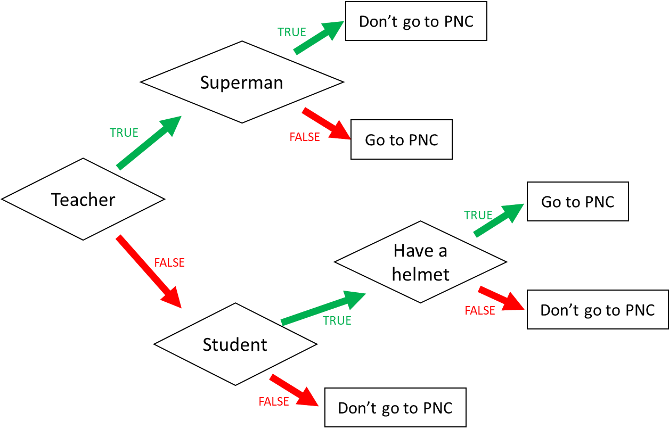

1. I am a teacher and I am superman, can I go to PNC?
2. I am not a teacher and not a student, can I go to PNC?
3. When can I go to PNC? (Express the condition using a Boolean expression)

I go to PNC if:

Not teacher AND student AND have a helmet

Ex 2: What do I eat?

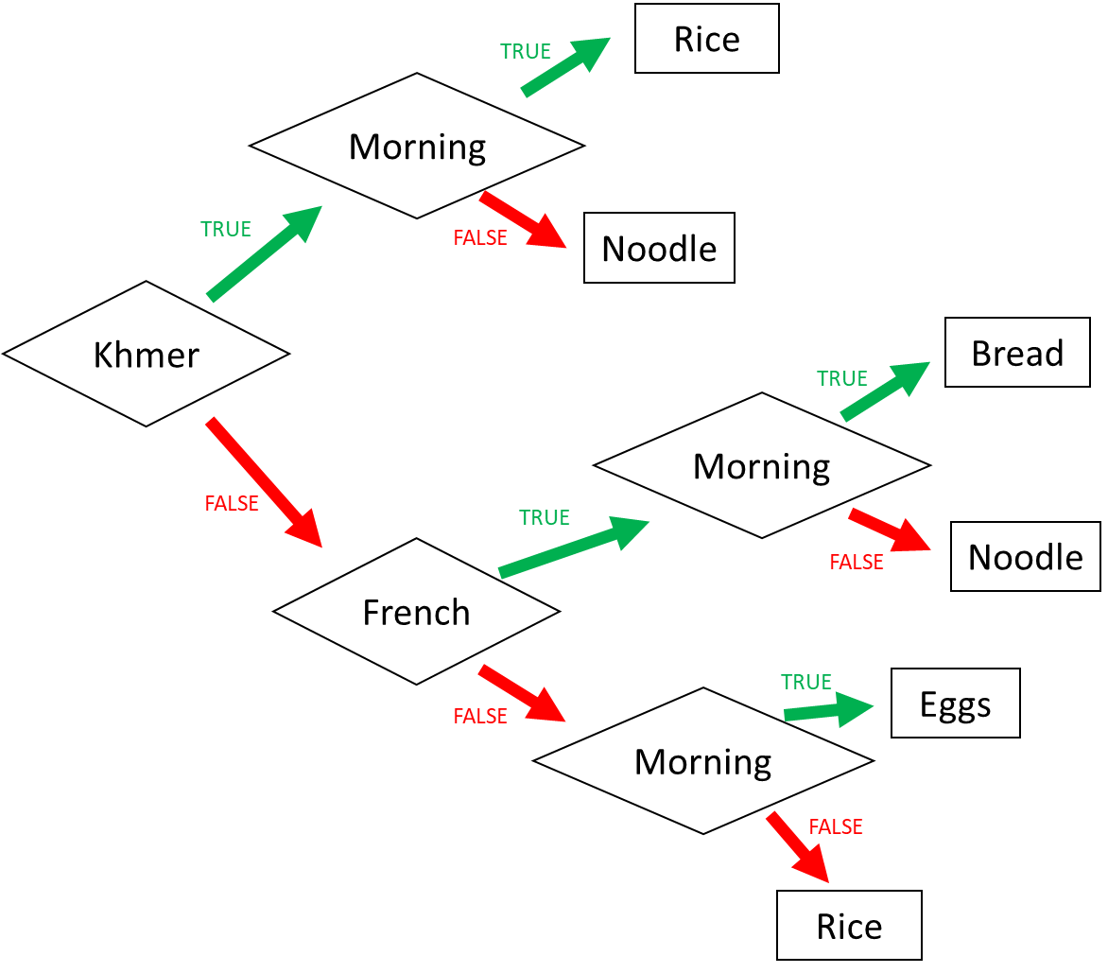

1. I am Khmer and it is the evening. What do I eat?

2. I am French and it is the morning. What do I eat?

3. I am American and it is the morning. What do I eat?

4. When do I eat rice? (Express the condition using a Boolean expression)

I eat rice if:

Khmer AND morning OR not khmer AND not french AND not morning

Ex 3: Do I go to the pool?

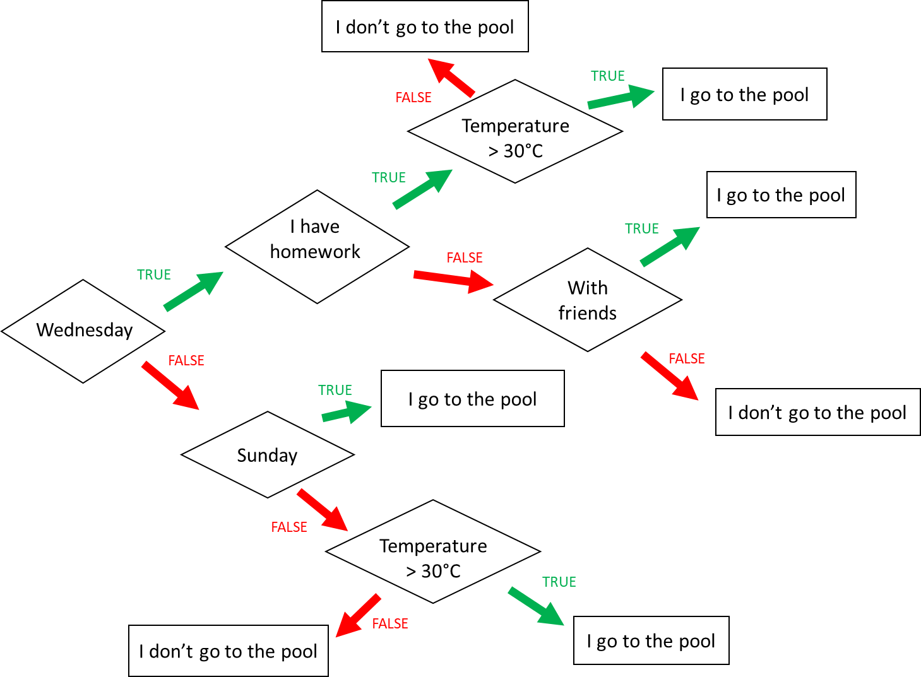

**Input 1 :**

* Wednesday
* Temperature = 31°C
* **Homework**

🡪 Do I go to the pool ?

no

**Input 2 :**

* Monday
* Temperature = 35°C
* I have no friend

🡪 Do I go to the pool ?

yes

**Input 3 :**

* Wednesday
* I have **no** homework
* I’m with friends
* Temperature = 28°C

🡪 Do I go to the pool ?

no

When do I go to the pool ? (Express the condition using a Boolean expression)

I go to the pool if :

I go to the pool if

Wednesday AND I have homework AND temperature > 30°C OR

Wenesday AND I haven’t homework AND with friends OR not wenesday AND not Sunday OR not wenesday AND not Sunday AND temperature >30°C

Ex4: Do I create a Facebook account?

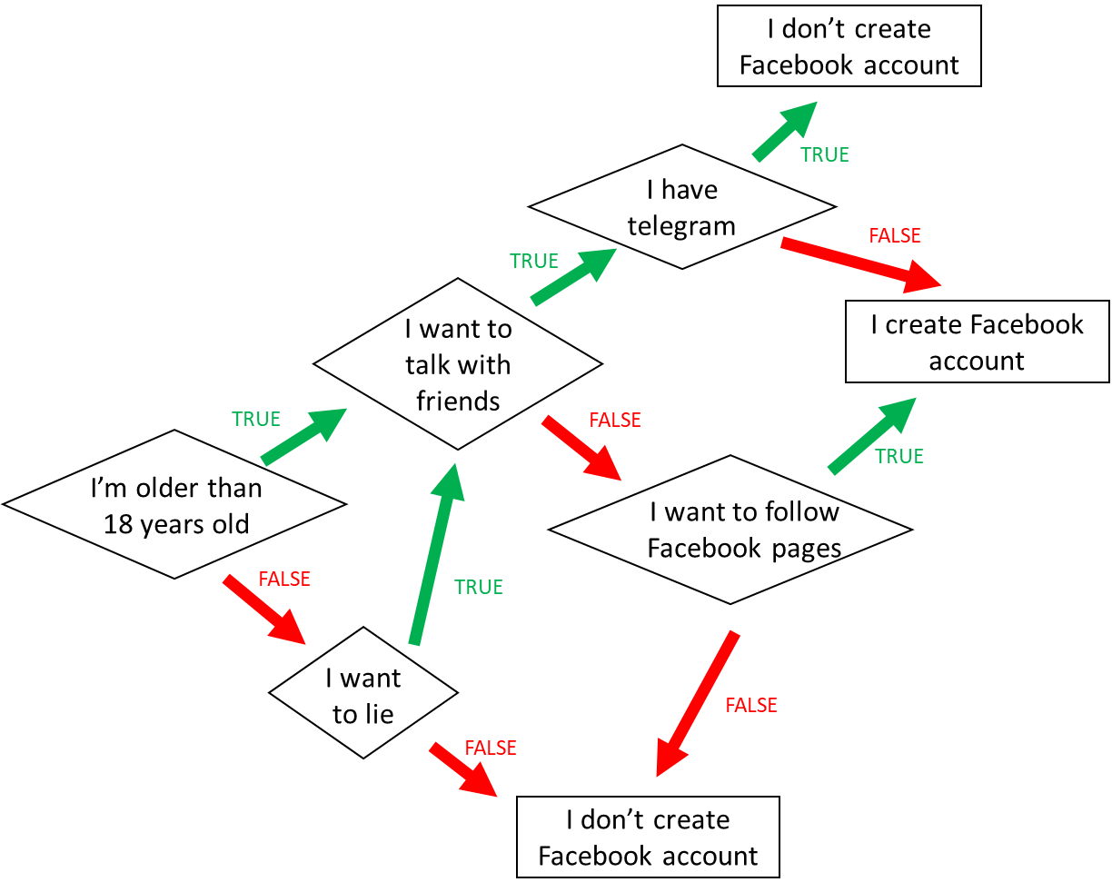

1. When do I create a Facebook account? (*Express the condition using a Boolean expression)*

I’m older than 18 years old AND i want to talk with friends OR i want to follow facebook pages.

1. When **don’t I** create a Facebook account? *(Express the condition using a Boolean expression)*

I’m older than 18 years old AND i want to talk with friends AND i have telegram OR i want to lie

Ex5: Create the chart flow

**Q1** Complete the char flow to follow those rules:

* If I am a girl and it is sunny, I wear a skirt
* If I am a girl and it is not sunny, I wear jeans
* If I am a boy and it is sunny, I wear a short
* If I am a boy and it is not sunny, I wear jeans

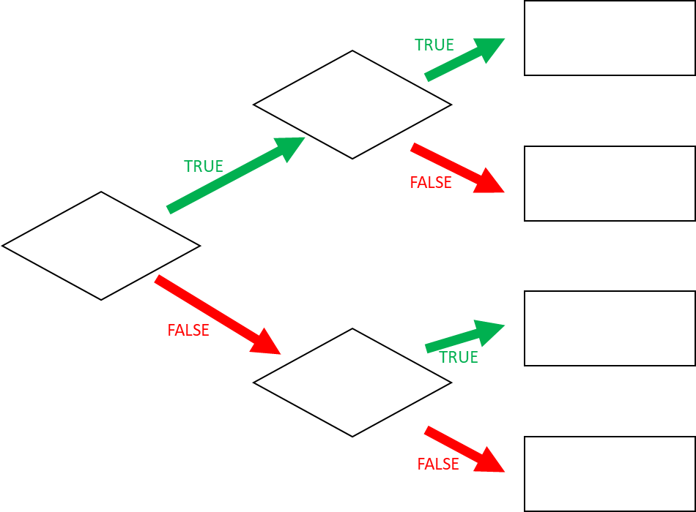

I wear a skirt

I wear jeans

I wear a jeans

I wear a short

It’s sunny

It’s sunny

I’m a girl

**Q1** When do I wear jeans? *(Express the condition using a Boolean expression)*

I’m a girl AND it’s not sunny, OR I’m a boy AND it’s not sunny, I wear jeans